Practical No: 05

**Q1.** Two random samples are drawn from two normal populations Sample-I 20,16,26,27,22,23,18,24,19,25

Sample-II 27,33,42,35,32,34,38,28,41,43,30,47. Obtains the estimated variance of the population and test at 5% level of significance whether the two populations have the same variance.

x=c(20,16,26,27,22,23,18,24,19,25)

y=c(27,33,42,35,32,34,38,28,41,43,30,47)

ab=var.test(x,y) print(ab) **Output:**

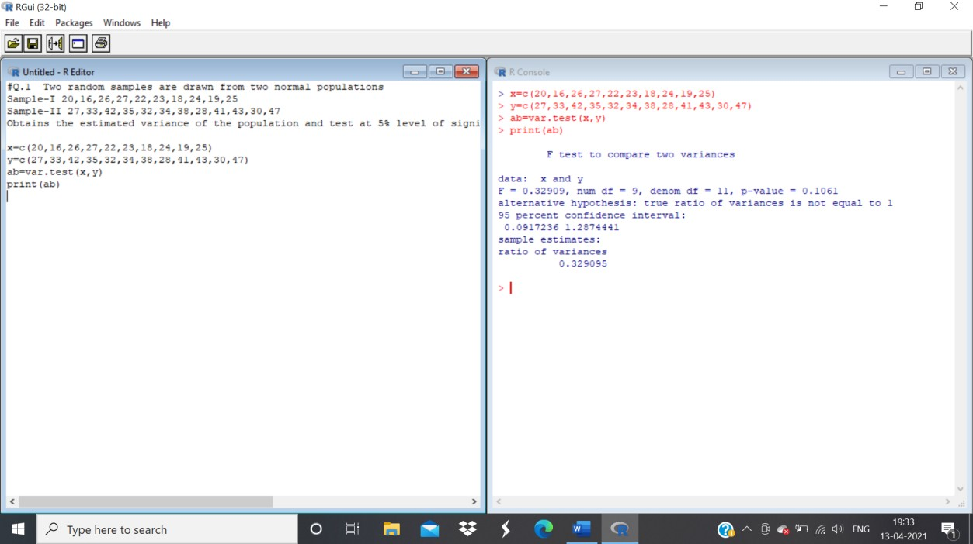

**Ans:** The p-value of F-test is p=0.1.61 which is greater than the alpha level 0.05. In conclusion, there is no difference between the two samples.

**Q2.** The following data refer to yield of wheat in quintals on equal area in two agriculture block A and B

|  |  |  |  |
| --- | --- | --- | --- |
|  | No. of Plots | Mean | Variance |
| Block A | 8 | 60 | 50 |
| Block B | 6 | 51 | 40 |

Use F-test to determine that variance of A is greater then B using 10 % level of significance.

x=rnorm(8,mean=60) y=rnorm(6,mean=40) var.test(x,y,alternative="two.sided") **Output:**

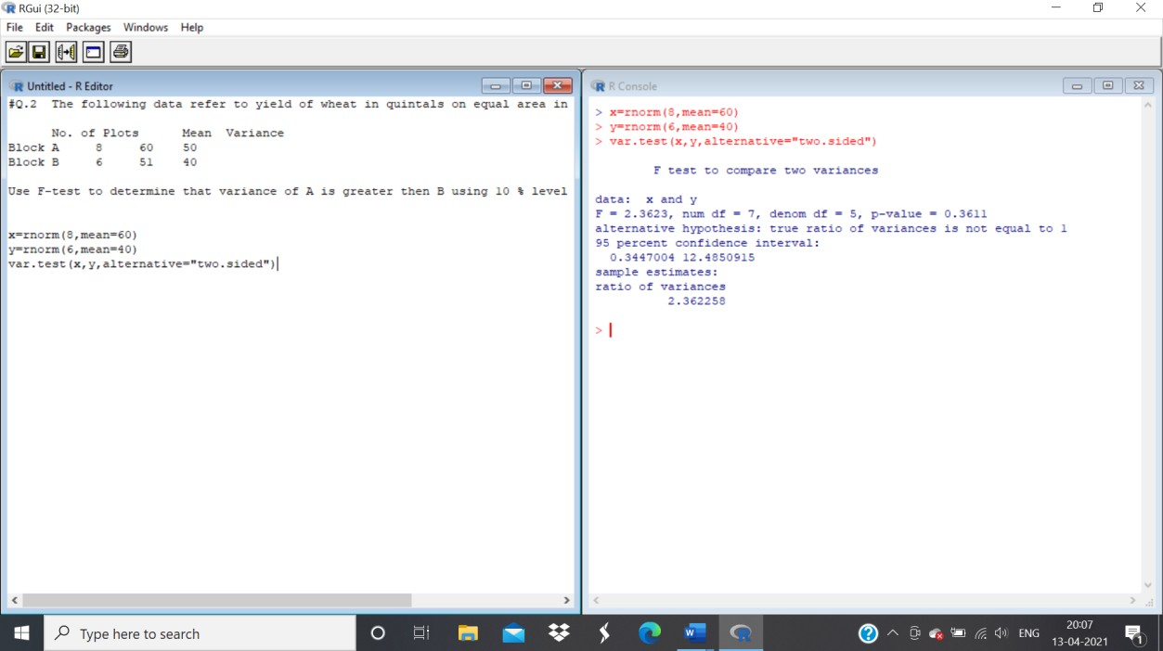

**Ans:** The p-value of F-test is 0.5418 is less than the level of significance

**Q3.** The following are price (in Rs) of the commodity in the sample of the shops selected at randomfrom different cities

City A 74.10,77.70,75.35, 74.00,73.80, 79.30,75.80,76.80,77.10,76.40

CityB 70.80,74.90,76.20,72.80,78.10,74.70,69.80,81.20

Is it reasonable to say variances of the price in both cities are same(use F-test) . Is it reasonable to say average price in both cities are same(use T-test)

x=c(74.10,77.70,75.35, 74.00,73.80, 79.30,75.80,76.80)

y=c(70.80,74.90,76.20,72.80,78.10,74.70,69.80,81.20)

ab=var.test(x,y) print(ab)

cd=t.test(x,y,paired=TRUE,alternative="less") print(cd)

# Output:

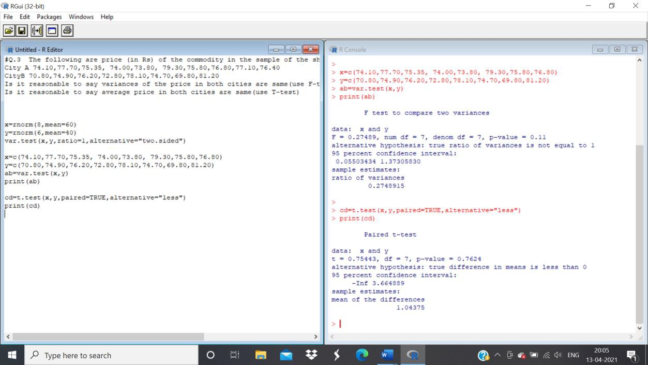

**Ans**: The p-value of F-Test 0.11 is greater than 0.05, we can conclude that the two variance of the price in both cities are same

The p-value of T-test i=0.7624 is greater than 0.05, we can conclude that the average price in both the cities are same

**Q4.** y1=45, 87, 123, 120, 70)

y2= 51, 71, 42, 37, 51, 78, 51, 49, 56, 47, 58

Check if the hypothesis two are having same variance

y1=c(45, 87, 123, 120, 70)

y2=c(51, 71, 42, 37, 51, 78, 51, 49, 56, 47, 58)

ab=var.test(x,y) print(ab)

# Output:

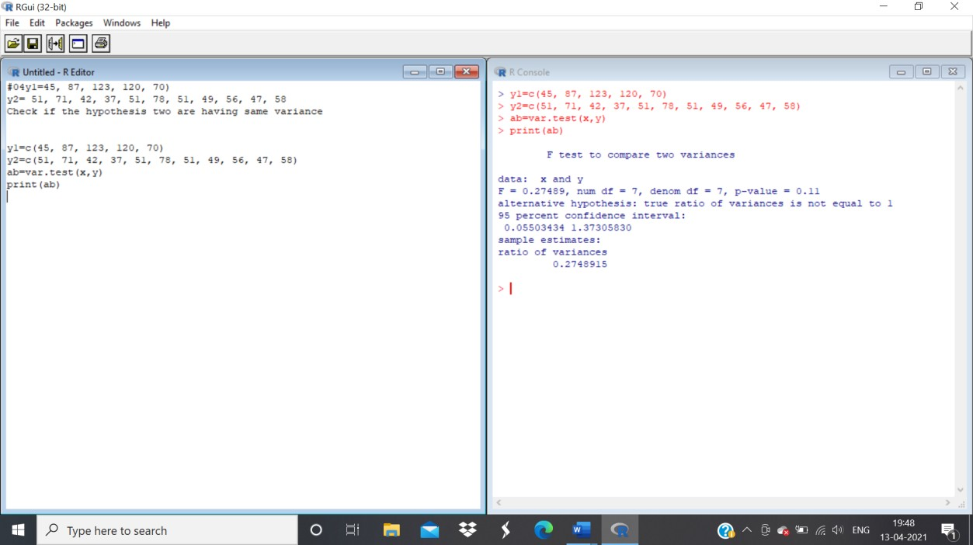

**Ans:** The p-value of F-test 0.11 is greater than the level of significance 0.05. The conclusion is that the variance is the same.

**Q5.** Generate two random sample one of size 300 and mean 45 and other of size 65 and mean

44. Check the variance of two data are equal

a=rnorm(300,mean=45) b=rnorm(65,mean=44) cd=var.test(a,b) print(cd)

# Output:

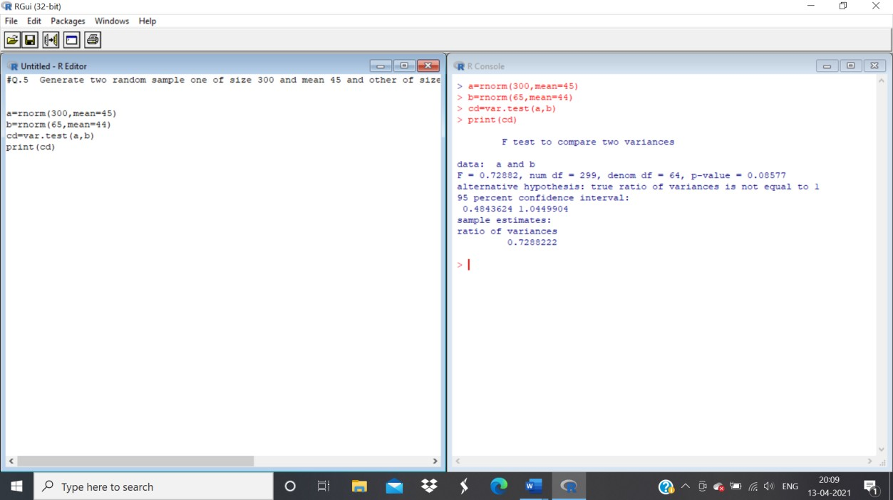

**Ans:** The p-value of F-test 0.3616 is greater than the significance level 0.05. The variance of two data are equal.

**Q6.** Below are given the gain in weights (in lbs) of pigs fed on two diets A and B Gain in weight Diet A: 25, 32, 30, 43, 24, 14, 32, 24, 31, 31, 35, 25

Diet B: 44, 34, 22, 10, 47, 31, 40, 30, 32, 35, 18, 21, 35,29, 22is it reasonable to say two variance are equal.

x=c(25, 32, 30, 43, 24, 14, 32, 24, 31, 31, 35, 25)

y=c(44, 34, 22, 10, 47, 31, 40, 30, 32, 35, 18, 21, 35,29, 22)

ab=var.test(x,y) print(ab) **Output:**

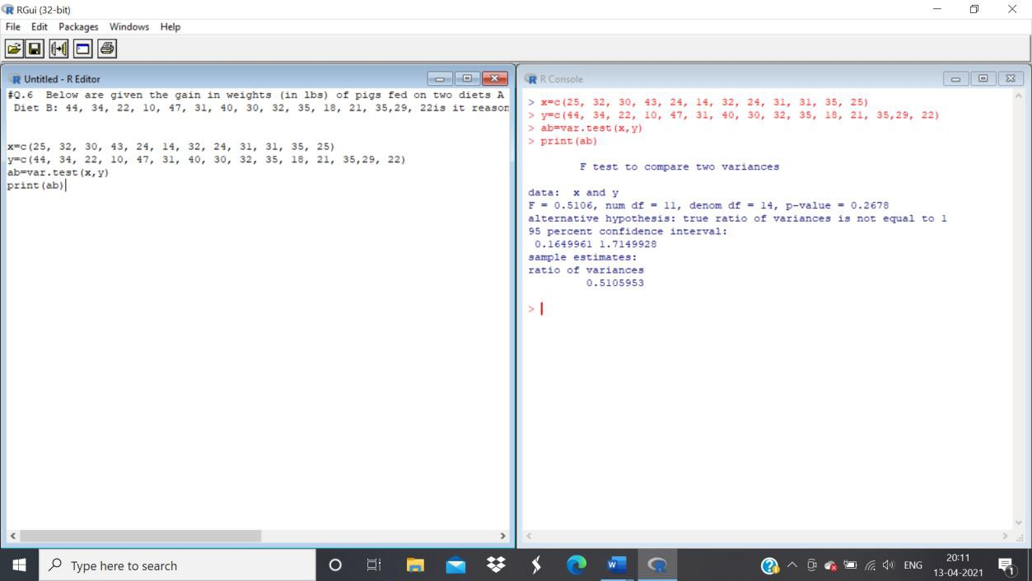

**Ans:** The p-value of F-test 0.278 is greater than the level of significance 0.05. It concludes that that the vairance of the weights is equals.

**Q7.** Use the following data to test whether the attributes condition of home and condition of child are independent.

|  |  |  |  |
| --- | --- | --- | --- |
|  |  | Condition of Home | |
|  |  | Clean | Dirty |
| Condition of child | Clean | 70 | 50 |
| Fairly Clean | 80 | 20 |
| Dirty | 35 | 45 |

(Use chi-square test to check the independence)

cat("Enter observed frequencies column wise" \n) x=c(70,80,35,50,20,45)

y=matrix(x,nrow=3,ncol=2) ab=chisq.test(y,correct=F) ab

print(ab$observed);print(ab$expected);cv=ab$statistic;pv=ab$p.value print(cv)

print(pv)

# Output:

